How To - Revit File Rename App

|  |  |  |
| --- | --- | --- |
| Release Date | Version | Comments |
| 08/01/2013 | 0.1 | Draft |
| 17/06/2013 | 0.2 | Icon Update |
| 14/08/2013 | 0.3 | User Interface overhaul |

# Summary – File Rename Tab

The Revit File Rename App is a standalone add-in meant to speed up naming of PDF’s and DWG according to project policy.

|  |  |  |
| --- | --- | --- |
| App Name | Icon | App Usage |
| * File Rename | Icon-Reload Family.png | Creates any number of dependant views by level |

Within the Revit user interface the File Rename app can be found under the BVN Tools tab:

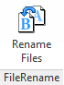

# File Rename - PReface

The ‘File Rename’ app is speeds up dramatically the naming of PDF’s and DWG’s in accordance with a project naming policy. It uses information from Revit, i.e. the Revision number, to name files correctly. This reduces human errors and speeds up the documentation issue process.

# File Rename – Main User Interface

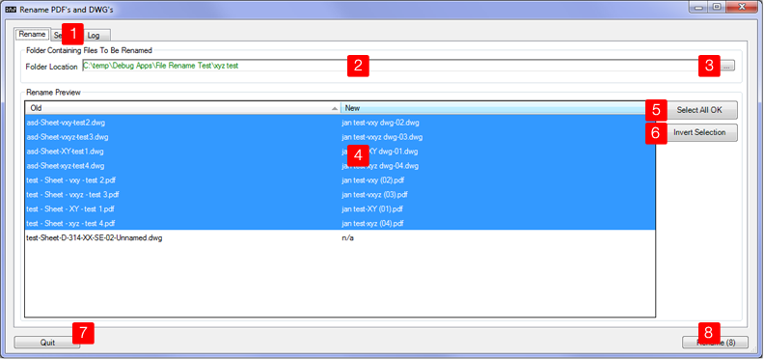

|  |  |
| --- | --- |
| 1 –Tab selector | Switches between the main, settings and log tab. |
| 2 – Browse to Folder | The path to your folder containing the files to be renamed. In can directly be copied and paste from windows explorer. |
| 3 – Browse To Folder Dialogue | Shows a standard Windows Folder Browse Dialogue which can be used to locate the folder containing all pdf’s and dwg files to be renamed. |
| 4 – Live Preview | Shows existing files names in left hand side column and how they will be named in the right hand side column. Any files which don’t have a matching sheet in the project file displays an ‘n/a’ in the right hand side column. |
| 5 – Select All Ok | Will select all files in the preview window which have a matching sheet associated with them. |
| 6 - Invert Selection | Will invert the selection in the live preview. |
| 7 - Quit | Cancels any actions and returns to Revit |
| 8 - Rename | Will start the rename process of all files found in the target folder. After completion a ‘Finished’ Message will be displayed. |

# File Rename – Settings

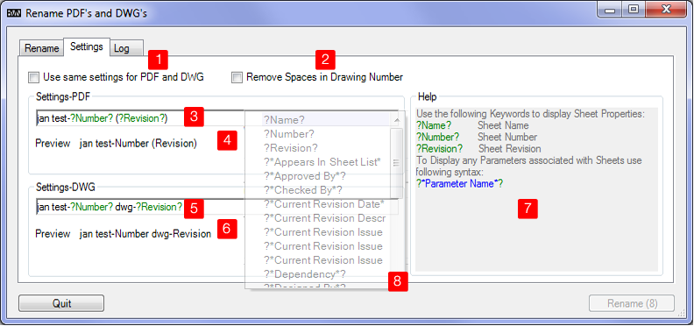

|  |  |
| --- | --- |
| 1 – Use same settings for PDF and DWG r | The same renaming rules will be applied for PDF’s and DWG files. The Settings DWG group 5) will be disabled when this option is ticked. Note: quite often PDF’s and DWG’s require ever so slightly different settings for web based documentation systems like Aconex. |
| 2 – Remove Spaces in drawing numbers | Sometimes long drawing numbers in Revit have spaces in them to enable Revit to format (line break) them properly in call outs. This option removes those spaces since they are purely of cosmetical nature. |
| 3 /5 – Settings PDF/ DWG | These fields govern how a file (pdf or dwg) will be named.  A file name can be made up of:   * Text - simple text which is always the same for all sheets-coloured black * Keywords - these are bracketed by a ? – coloured green * Parameters associated with a sheet - these are bracketed by a ?* - coloured blue   Keywords, Text and parameters can be arranged in any order required. |
| 4/6 Generic Preview | This preview field gives an indication on how the files will be formatted. |
| 7 – Help | A quick reference on how to use the settings fields. |
| 8 - AutoComplete | When start typing into the settings fields an auto complete window will appear as soon as one types ?. The window will show all available keywords and parameters. |

# File Rename – LOG User Interface

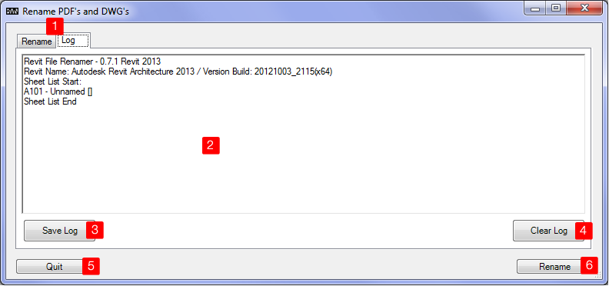

|  |  |
| --- | --- |
| 1 –Tab selector | Switches between the main and log tab. |
| 2 – Log window | This window provides the following information:   * Revit file rename version number * Revit Version and Build * Sheet list of all sheets found in model * Progress report |
| 3 – Save Log | Saves the log window as text file for debugging purposes. |
| 4 – Clear log | Clears the log window |
| 5 – Quit | Cancels any actions and returns to Revit |
| 6 - Rename | Will start the rename process of all files found in the target folder. After completion a ‘Finished’ Message will be displayed.  Note: An error message at the end of the rename action does not necessarily means none of the files where renamed: if there are PDF’s in the target folder of documents not in the Revit project file (i.e. PDF’s from word documents like specifications or schedules) the rename app will fail to rename those documents and produce an error message. Check the log tab for further details |